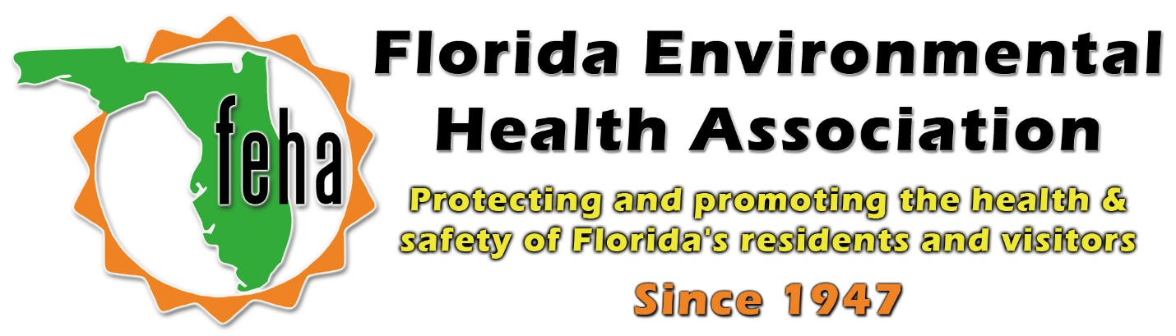

2021 Virtual FEHA Annual Education Meeting
October 13th-15th 2021
Session Title: Environmental Health Emergency Preparedness
Part 1 and 2
Date: Wednesday October 13th
Time: Part 1: 9am-10:30am
Part 2: 11am-12:30pm
Speakers:
Part 1:
Trisha Dall, DOH-Okaloosa County Environmental Health Director, will discuss on County Level EH Preparedness;
Michael Mitchell, Environmental Preparedness Coordinator, will discuss State Level EH Preparedness;
Victor Faconti, DOH-Okeechobee County Environmental Health Director, will discuss EH Preparedness activations and deployment.

Part 2:
Tim Wallace, Department of Health Environmental Consultant, will discuss Indoor Contaminates;
Summer Williams, Florida Department of Agriculture Emergency Response Coordinator, will discuss DACS Response.
Moderator:
Michael Mitchell, CEHP

Agenda
Part 1:
0900 -0930a Trisha: Intro/ Prep to EH Preparedness
0930-1000a Mike Mitchell State Level EH Preparedness
1000-1030a Victor Faconti EH Preparedness: Activation and deployment
Part 2:
1100 – 1140a Tim Wallace Indoor Air / Mold after hurricane flood
1140a-1230p Summer Williams / FDACS discussion

