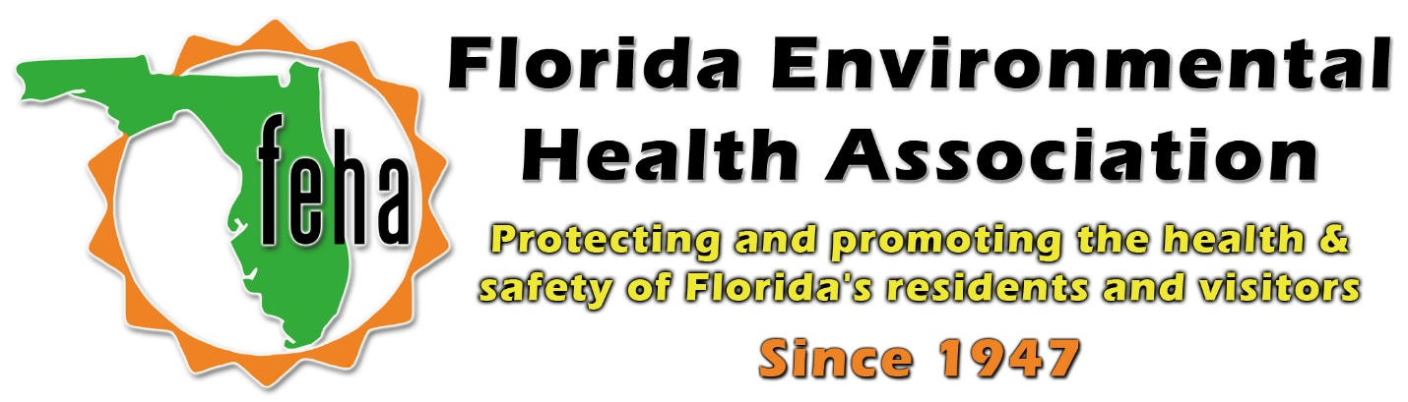

2021 Virtual FEHA AEM
October 13th-15th 2021
Session Title: Roles and advantages of database management systems
Date: Friday October 15th
Time: 3:45pm-5pm
Speaker: Cameron Garrison, COO of HealthSpace

Start: 3:45pm
End: 5pm

