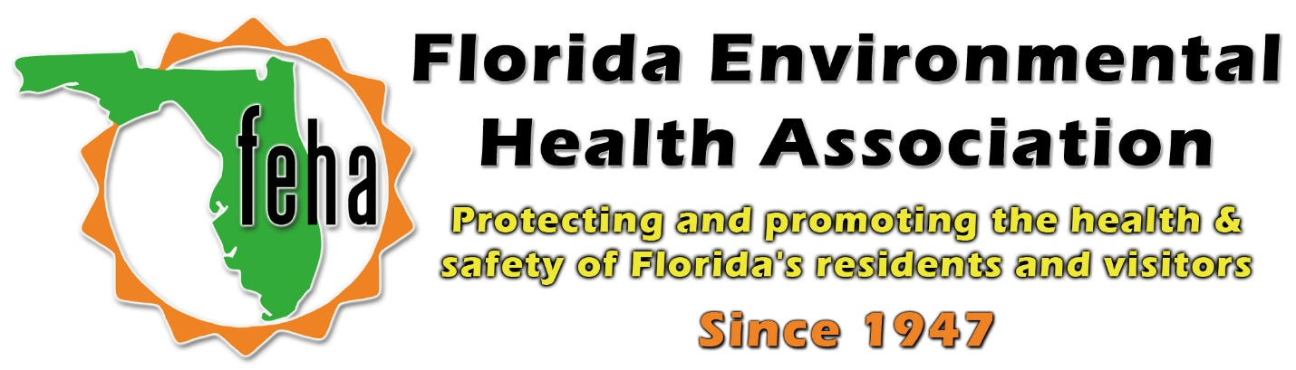

2021 Virtual FEHA Annual Education Meeting
October 13th-15th 2021
Session Title: Current Topics in Drinking Water
Date: Thursday October 14th
Time: 11-12:30pm

Speakers:
11am: David N. Arnold, P.G., Manager
Water Well Construction Program
Southwest Florida Water Management District
Title: Water Well Construction and Design Using Geologic Parameters to Prevent Contamination.

11:45pm: Cody Ray,
Director of North American Business Development
Luminultra Microbial Monitoring
Title: Rapid Detection of Legionella Bacteria, Two Weeks to Two Hours
12:30pm: End

